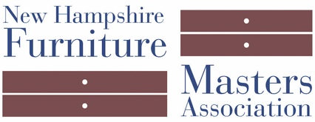
FOR IMMEDIATE RELEASE
DATE: March 23, 2018
CONTACT: Pam Sullivan, news@sullivancreative.com, (603) 228-0836

The New Hampshire Furniture Masters Association Holds
Reception for Exhibition – Looking Back: Vintage Works
Friday, April 6th 5pm – 7pm, Concord, NH

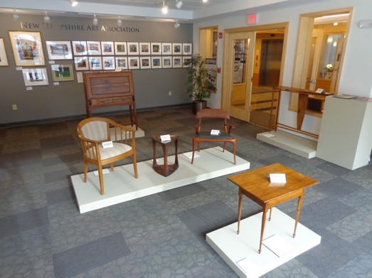
Concord, NH — The New Hampshire Furniture Masters Association will host a reception for their Looking Back: Vintage Works exhibition on April 6th from 5pm – 7pm at their Gallery on 49 South Main Street, Concord, NH. Each piece of work on display is at least 25 years or older and predates the formation of the group. Visit the Gallery Monday – Friday 8:30am – 5pm.

At the reception, meet the makers of these pieces of fine furniture and discuss earlier approaches the Masters took when crafting them. See how time can effect the color, pattern, and overall feel of a piece of furniture. The furniture on display in this exhibition is not for sale but serves as an example of what can be made or commissioned from a Furniture Master.

The reception for Vintage Works is being held in conjunction with the League of NH Craftsmen’s Fairy Tales & Fantasies exhibition, which is on display in the Gallery of the League of NH Craftsmen Headquarters, which is across the hall. The Furniture Masters Gallery is open Monday through Friday from 8:30am – 5pm on 49 South Main Street, Concord, NH. Vintage Works will be on display until June 11th. For more information about the New Hampshire Furniture Masters Association, visit http://furnituremasters.org/.

About New Hampshire Furniture Masters Association
The New Hampshire Furniture Masters Association (NHFM) was formed in 1993 by a core group of furniture makers and several Concord-area business men and women. The founders had one goal in mind: to build public awareness of New Hampshire’s fine furniture makers and to cultivate an audience for their goods closer to home. The Furniture Masters continue striving to spread awareness of their craft into the present, working collaboratively and leveraging their potent body of collective knowledge and experience to stimulate one another’s creative output.

###

