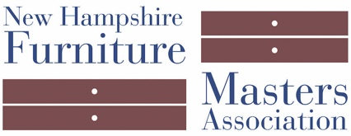
NEWS RELEASE
CONTACT: Pam Sullivan, E: news@sullivancreative.com P: (603) 228-0836
Photos available via email For Release: June 20, 2018

The New Hampshire Furniture Masters Association and the
American Furniture Masters Institute Open
New Exhibition Showcasing Prison Outreach Programs
June 12th – September 11th, 2018

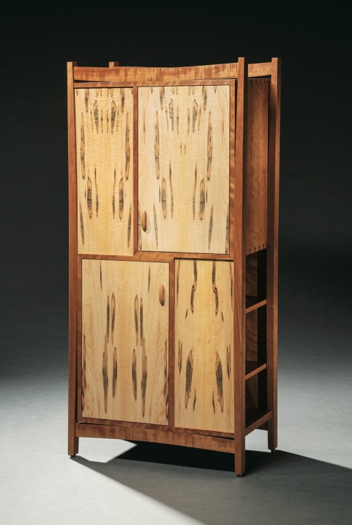
Concord, NH — The New Hampshire Furniture Masters Association presents On the Street – Works from the NH & Maine Prison Outreach Program, a new exhibition at their Gallery in Concord, NH. This exhibition features work by inmates participating in the Furniture Masters’ Prison Outreach Programs in the New Hampshire and Maine State Prisons. Visit the Gallery at 49 S. Main Street, Concord, NH Monday – Friday 8:30am to 5pm.

A variety of hand-crafted fine furniture is on display including jewelry boxes, tables and desks, a bookcase, and Shaker boxes. Many pieces of furniture on display are for sale. This exhibition is on display until September 11th.
Bookcase by Eric Windhurst
Photo by Bill Truslow
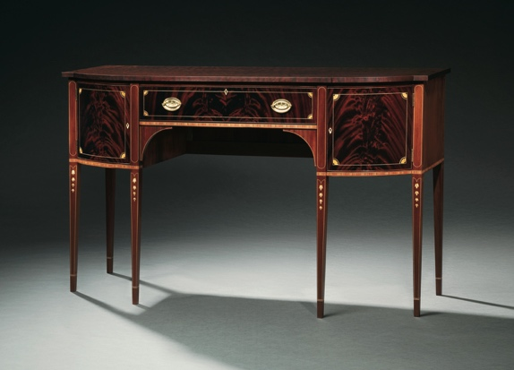
The Prison Outreach Program was founded in 1999 and is run by the Furniture Masters’ non-profit sister organization, the American Furniture Masters Institute. This program educates select inmates on the art of fine furniture making. Rotating members of the Furniture Masters volunteer their time to teach this program.
Federal Sideboard by Al Eason
Photo by Bill Truslow

The Furniture Masters will host a free open reception for On the Street Friday, June 29th from 5pm – 7pm at their Gallery in Concord, NH. This reception is being held in conjunction with the League of NH Craftsmen’s new exhibition Celebrating 85 – The Stevens Collection, which is on display across the hall in the Gallery of the League of NH Craftsmen Headquarters.

For more information about the New Hampshire Furniture Masters Association, visit http://furnituremasters.org/. For more information on the American Furniture Master Institute and the Prison Outreach Programs, visit http://furnitureinstitute.org/.

About the American Furniture Masters Institute
The American Furniture Masters Institute (AFMI) is the non-profit 501(c)(3) sister organization and vital arm of the New Hampshire Furniture Masters Association. AFMI supports educational endeavors that preserve the art of fine furniture making. For the past 15 years, the Institute has coordinated the Prison Outreach Program in New Hampshire and recently expanded the program to Maine.

About New Hampshire Furniture Masters Association
The New Hampshire Furniture Masters Association (NHFMA) was formed in 1993 by a core group of furniture makers and several Concord-area business men and women. The founders had one goal in mind: to build public awareness of New Hampshire’s fine furniture makers and to cultivate an audience for their goods closer to home. The Furniture Masters continue striving to spread awareness of their craft into the present, working collaboratively and leveraging their potent body of collective knowledge and experience to stimulate one another’s creative output.

###

