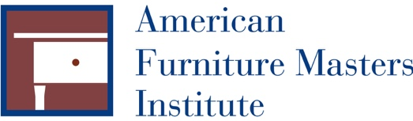
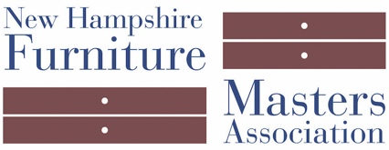

FOR IMMEDIATE RELEASE
DATE:
CONTACT: Pam Sullivan, news@sullivancreative.com, (603) 228-0836

The American Furniture Masters Institute
Awarded Grant from Madelaine G. von Weber Trust

CONCORD, NH — The American Furniture Masters Institute (AFMI) was recently awarded a grant from the Madelaine G. von Weber Trust to aid in the redesign and development of their website. AFMI is the nonprofit 501(c)(3) sister organization of the New Hampshire Furniture Masters Association. This new website will share the entities of both organizations.

A wide scope of work will be done in order to create a website that not only reflects current industry standards, but also is representative of the high standards and quality craftsmanship AFMI and The Furniture Masters represent. Sullivan Creative of Concord, NH was selected to build this website because of their expertise, knowledge, a niche of working with similar organizations.

About the American Furniture Masters Institute
The American Furniture Masters Institute (AFMI) is the non-profit 501(c)(3) sister organization and vital arm of the New Hampshire Furniture Masters Association. AFMI supports educational endeavors that preserve the art of fine furniture making. For the past 15 years, the Institute has coordinated the Prison Outreach Program in New Hampshire and recently expanded the program to Maine. AFMI also oversees and administers the Furniture Masters’ Alden Artisan Advancement, a scholarship program that is awarded each year to an emerging furniture maker.

About New Hampshire Furniture Masters Association
The New Hampshire Furniture Masters Association (NHFM) was formed in 1993 by a core group of furniture makers and several Concord-area business men and women. The founders had one goal in mind: to build public awareness of New Hampshire’s fine furniture makers and to cultivate an audience for their goods closer to home. The Furniture Masters continue striving to spread awareness of their craft into the present, working collaboratively and leveraging their potent body of collective knowledge and experience to stimulate one another’s creative output.

###

