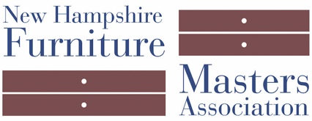
FOR IMMEDIATE RELEASE
DATE: June 27, 2018
CONTACT: Pam Sullivan, news@sullivancreative.com, (603) 228-0836

Join the NH Furniture Masters at Castle in the Clouds
Sunday, July 15th, Moultonborough, NH

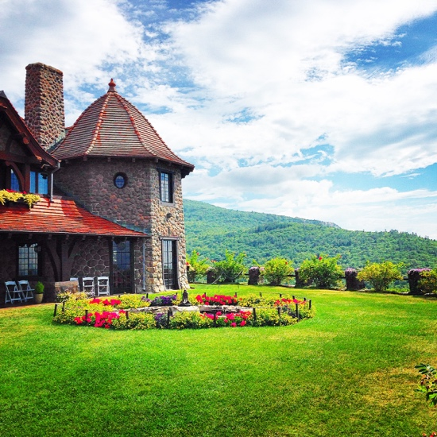
MOULTONBOROUGH, NH — The New Hampshire Furniture Masters Association will make a pop-up appearance on July 15th at Castle in the Clouds, 455 Mountain Road in Moultonborough, NH. This event features a Daytime Exhibit from 10am – 5:30pm and a ticketed Evening Reception from 6pm – 7:30pm.

During the Daytime Exhibit, participating Furniture Masters will be inside the Castle sharing the details of fine furniture making and explaining the designs and techniques used to make many of the Castle’s antique furnishings. This is an “added bonus” included with Castle admission.

At the Evening Reception, each Master will showcase a recent piece of their own work and discuss the design, creation, and inspirations behind their piece. Enjoy wine and hors d’oeuvres, celebrate art and craftsmanship, and take in the gorgeous views of Lake Winnipesaukee. Tickets for the Evening Reception are $25 per person. Space for this reception is limited – purchasing tickets in advance is highly recommended. To purchase tickets and learn more about this event, visit castleintheclouds.org.

Participating Masters: Terry Moore, Jon Brooks, Ted Blachly, Tim Coleman, Jeff Cooper and Invited Artists Duncan Gowdy, Owain Harris, and Evan Court.
This event is generously sponsored by Christopher P. Williams Architects.

About New Hampshire Furniture Masters Association
The New Hampshire Furniture Masters Association (NHFM) was formed in 1993 by a core group of furniture makers and several Concord-area business men and women. The founders had one goal in mind: to build public awareness of New Hampshire’s fine furniture makers and to cultivate an audience for their goods closer to home. The Furniture Masters continue striving to spread awareness of their craft into the present, working collaboratively and leveraging their potent body of collective knowledge and experience to stimulate one another’s creative output.

###

