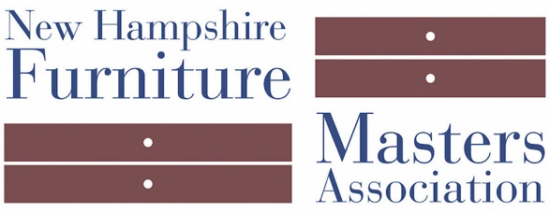

FOR IMMEDIATE RELEASE
March 14, 2018
CONTACT: Pam Sullivan, news@sullivancreative.com; (603) 228-0836

Invited Artists Join the New Hampshire Furniture Masters Association

The New Hampshire Furniture Masters Association (NHFMA) announced the selection of Evan Court and Duncan Gowdy as 2018 Invited Artists. Invited Artist are nominated individuals who present their work to the Furniture Masters’ jury for careful review. To be selected, Invited Artists will have reached a mastery level of fine furniture making, proving that their work is detailed, unique, and an active participant in the evolution of the craft.

“Furniture making is a timeless craft, and we are continuously seeking new members who are producing at the Master level,” David Lamb, Co-Chairman of the New Hampshire Furniture Masters explained. “Evan and Duncan have distinct aesthetics and exceptional technique and that is what drew us to them. When we add new members, we bring inspiration to our members and an expanded reach of collectors and admirers.”
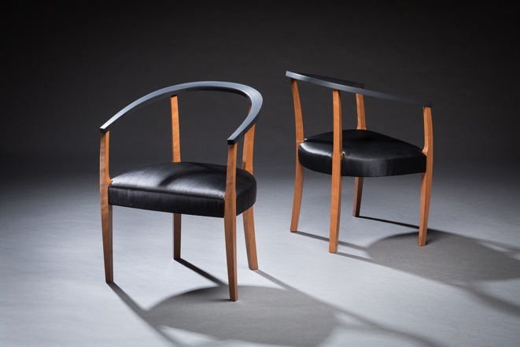
Invited Artist Evan Court is a graduate of North Bennet Street School where he studied furniture making and cabinetry. He creates works with an elegant modern aesthetic, and while grounded in traditional methods and materials, Court's finished pieces are uniquely his own. His work has appeared in magazines, and in 2017 he earned "Best In Show" during an exhibition at Maine College of Art. His studio is in Rollinsford, N.H., with an online gallery at http://www.evanlcourt.com.
Photo Credit: Bill Truslow
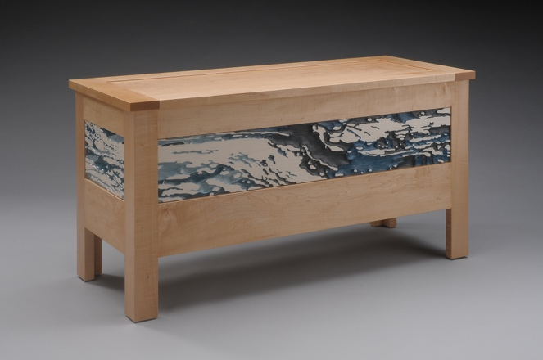
Invited Artist Duncan Gowdy makes furniture that incorporate his original photography and objects whose shapes pique his interest. From both veins of inspiration, he builds pieces that are utilitarian (with a few exceptions, he notes) and engage the mind. His use of photography as decorative effect on wood is dramatic; in his pieces that incorporate objects there is an element of surprise. Gowdy is a woodworking educator, his work has appeared in magazines and has toured in national exhibitions. Gowdy’s online gallery at http://www.duncangowdy.com.
Photo Credit: Dean Powell
###

About New Hampshire Furniture Masters Association:
The New Hampshire Furniture Masters Association (NHFM) was formed in 1993 by a core group of furniture makers and several Concord-area business men and women. The founders had one goal in mind: to build public awareness of New Hampshire’s fine furniture makers and to cultivate an audience for their goods closer to home. The Furniture Masters continue striving to spread awareness of their craft into the present, working collaboratively and leveraging their potent body of collective knowledge and experience to stimulate one another’s creative output. Information is available at:furnituremasters.org

